

**ARYABHATTA COLLEGE**

**Internet Technologies Practical File**

**Name : Pratham Gwari**

**Roll Number : 20059570050**

**Course : B.Sc(Hons) Computer Science**

**Year : III**

**Semester : V**

Submitted By Submitted To

Pratham Gwari Mr. R.K Sharma

|  |  |  |
| --- | --- | --- |
| **Serial Number** | **Question** | **Page Number** |
| **1** | Display your systems IP Address, Subnet mask using ipconfig, and find out the network address and the maximum number of systems possible on your network and range of IP addresses available to these systems. |  |
| **2** | With help of ping, check if you are connected to other systems of your network and find the route to connect to that system using tracert. List all the processes which are using ports for TCP protocol. |  |
| **3** | Create an HTML page that shows information about you, your course, hobbies, address, and your plans. Use CSS for styling of HTML page so that looks nice. |  |
| **4** | . Create an HTML page with the sole purpose to show multiplication tables of 2 to 10 (row-wise) created by JavaScript. Initially, the page is blank. With help of setInterval function print a row every 5 seconds in different colors and increasing font size. |  |
| **5** | . Create an HTML page with a paragraph written on it and under which 9 buttons are placed in a 3X3 grid. The first row is for buttons labeled with colors names Red, Green, and Blue, the second row with numbers 10, 20, 30, and the third row with different font names. Click event of each of the buttons should make the appropriate change in the style of paragraph. |  |
| **6** | Create a form that takes data about a pet. The form must be well designed and should accept the pet’s name, age, weight, type, and what it likes most. At the submission of this form create a Pet object in JavaScript filled with these values and log that object and equivalent JSON on the console. |  |
| **7** | Store JSON data of few pets that you created in previous practical in a JSON file (copy from console output of previous program to a .json file). Using AJAX, load data from the file and display it in a presentable way using HTML and CSS. |  |
| **8** | Create a plain HTML page for B.Sc. Hons CS course, mentioning details like fee, eligibility criteria, papers with names and credits, and future possibilities after the course. A button for styling should be there at bottom of the page. On clicking on this button JavaScript should redesign the complete page using jQuery in a nice presentable way. |  |
| **9** | Create an HTML page for an image gallery which shows the use of BOOTSTRAP to rearrange and resize its contents on resizing the browser. |  |
| **10** | Create an HTTP server using Node.js which handles requests on port 10000 or a free port beyond 10000. Modify the server in such a way that opening localhost:10000 will display “Hello world, This is my Node.js server” on browser. |  |
| **11** | Create index.html file containing two forms for SignIn and SignUp. Submitting SignIn form should search for credentials in mysql database using server created in previous practical. On successful signin, a welcome page should be displayed. Submitting SignUp form should insert new entry for credentials in mysql database using server created in previous practical. On successful signup, user should be returned back to index.html. |  |

**Question 1**

Display your systems IP Address, Subnet mask using ipconfig, and find out the network address and the maximum number of systems possible on your network and range of IP addresses available to these systems.

**OUTPUT**

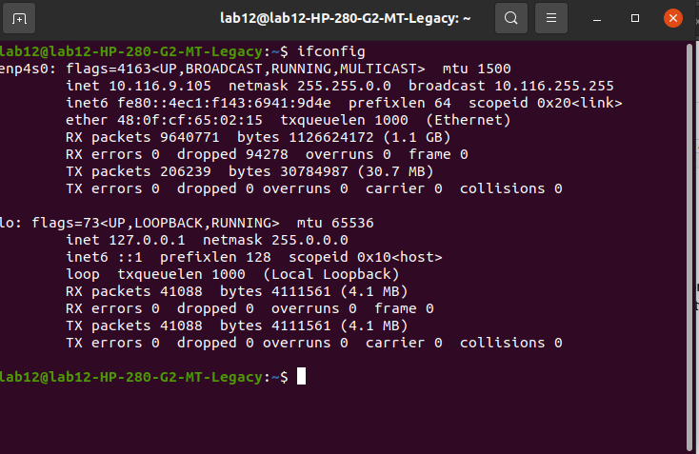

**Question 2**

Display your systems IP Address, Subnet mask using ipconfig, and find out the network address and the maximum number of systems possible on your network and range of IP addresses available to these systems.

**OUTPUT**

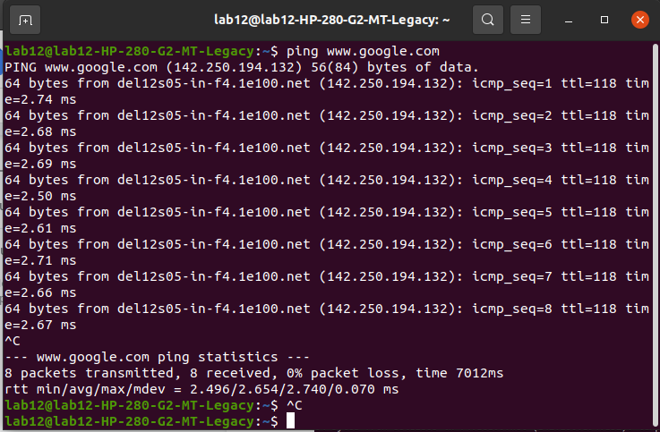

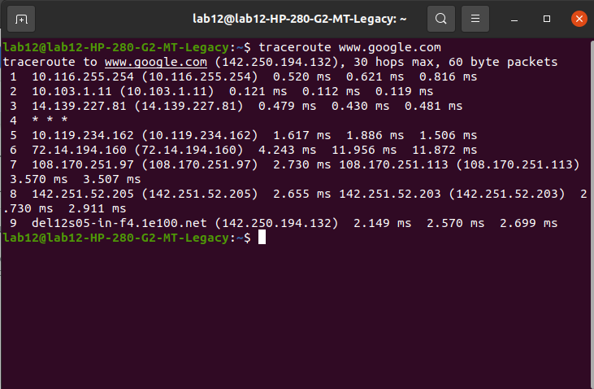

**Question 3**

Create an HTML page that shows information about you, your course, hobbies, address, and your plans. Use CSS for styling of HTML page so that looks nice.

Create an HTML page that shows information about you, your course, hobbies, address, and your plans. Use CSS for styling of HTML page so that looks nice.

**CODE**

<html>

  <head>

    <title>Networking Practical Q-3</title>

  </head>

  <style>

    div {

        display: block;

    }

    h1 {

      text-align: center;

      font-family: courier;

    }

    body {

        display: flex;

        flex-direction: row;

        justify-content: center;

        align-items: center;

    }

    .main-container {

        display: flex;

        flex-direction: column;

        width: fit-content;

        padding: 1rem;

        font-size: 1.5rem;

        justify-content: space-between;

    }

    .detail-container {

        margin-top: .2rem;

        margin-bottom: .2rem;

    }

    img {

        border-radius: 100%;

        border: 1px solid white;

        width: 10rem;

        height: 10rem;

    }

    .image-container {

        display: flex;

        justify-content: center;

        align-items: center;

        padding-top: 1rem;

        padding-bottom: 1rem;

        border-right: 2px solid black;

        padding-right: 1rem;

    }

    .parent-container {

        display: flex;

        border: 2px solid black;

        border-radius: .5rem;

        padding: 1.5rem;

    }

    .heading {

        font-weight: bolder;

        font-size: 1.5rem;

    }

  </style>

  <body>

    <div class="parent-container">

        <div class="image-container">

            <img src="profile pic.png" alt="">

        </div>

        <div class="main-container">

            <div class="detail-container">

                <span class="heading">Name</span>

                <span>Pratham Gwari</span>

            </div>

            <div class="detail-container">

                <span class="heading">Course</span>

                <span>BSC. hons. Computer Science</span>

            </div>

            <div class="detail-container">

                <span class="heading">Hobbies</span>

                <span>Programming, Gaming</span>

            </div>

            <div class="detail-container">

                <span class="heading">Address</span>

                <span>Nirman Vihar, East Delhi</span>

            </div>

        </div>

    </div>

</body>

</html>

**OUTPUT**

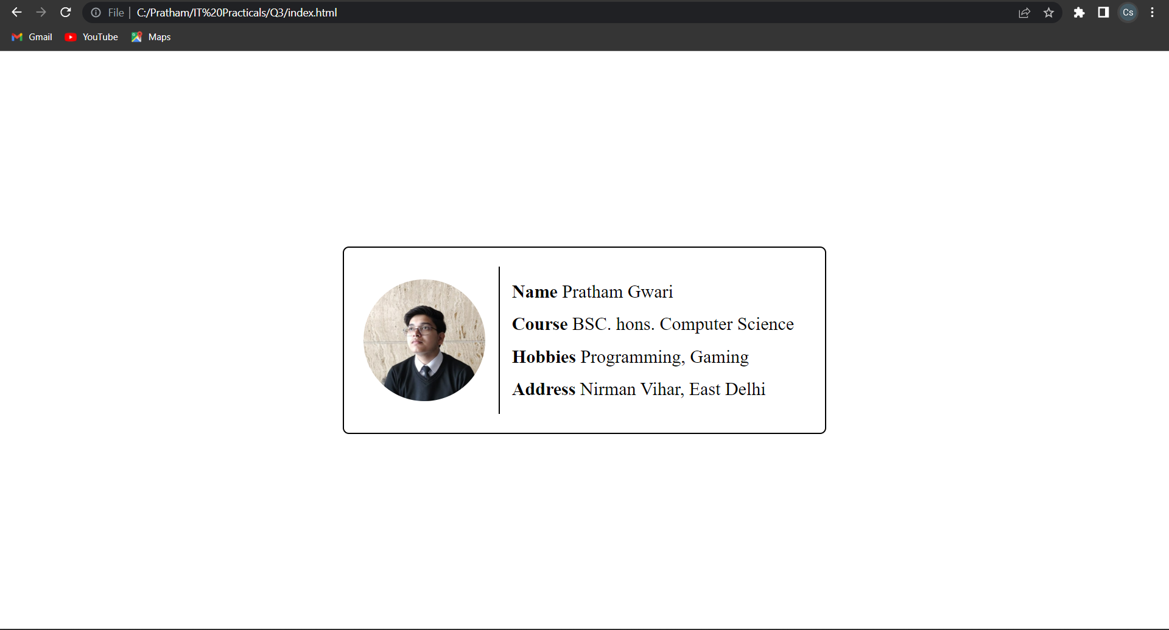

**Question 4**

Create an HTML page with the sole purpose to show multiplication tables of 2 to 10 (row-wise) created by JavaScript. Initially, the page is blank. With help of setInterval function print a row every 5 seconds in different colors and increasing font size.

**CODE**

<!DOCTYPE html>

<html>

  <head>

    <meta http-equiv="X-UA-Compatible" content="IE=edge" />

    <title>Q4</title>

    <meta name="description" content="" />

    <meta name="viewport" content="width=device-width, initial-scale=1" />

  </head>

  <style>

    body {

        background-color: #242224;

    }

  </style>

  <body>

    <div

      id="parent-div"

    ></div>

    <script>

      let n = 2;

      const backGroundColor = [

        "violet",

        "indigo",

        "blue",

        "green",

        "yellow",

        "orange",

        "red",

        "green",

        "pink",

      ];

      const parent = document.getElementById("parent-div");

      const saveInterval = setInterval(() => {

        const element = document.createElement("h3");

        element.textContent = `${n * 1} ${n * 2} ${n * 3} ${n * 4} ${n * 5} ${

          n * 6

        } ${n * 7} ${n * 8} ${n * 9} ${n * 10}`;

        element.setAttribute(

          "style",

          `font-size:${14 + n * 2}px;color:${backGroundColor[n - 2]}`

        );

        parent.appendChild(element);

        n++;

        if (n == 11) {

          clearInterval(saveInterval);

        }

      }, 1000);

    </script>

  </body>

</html>

**OUTPUT**

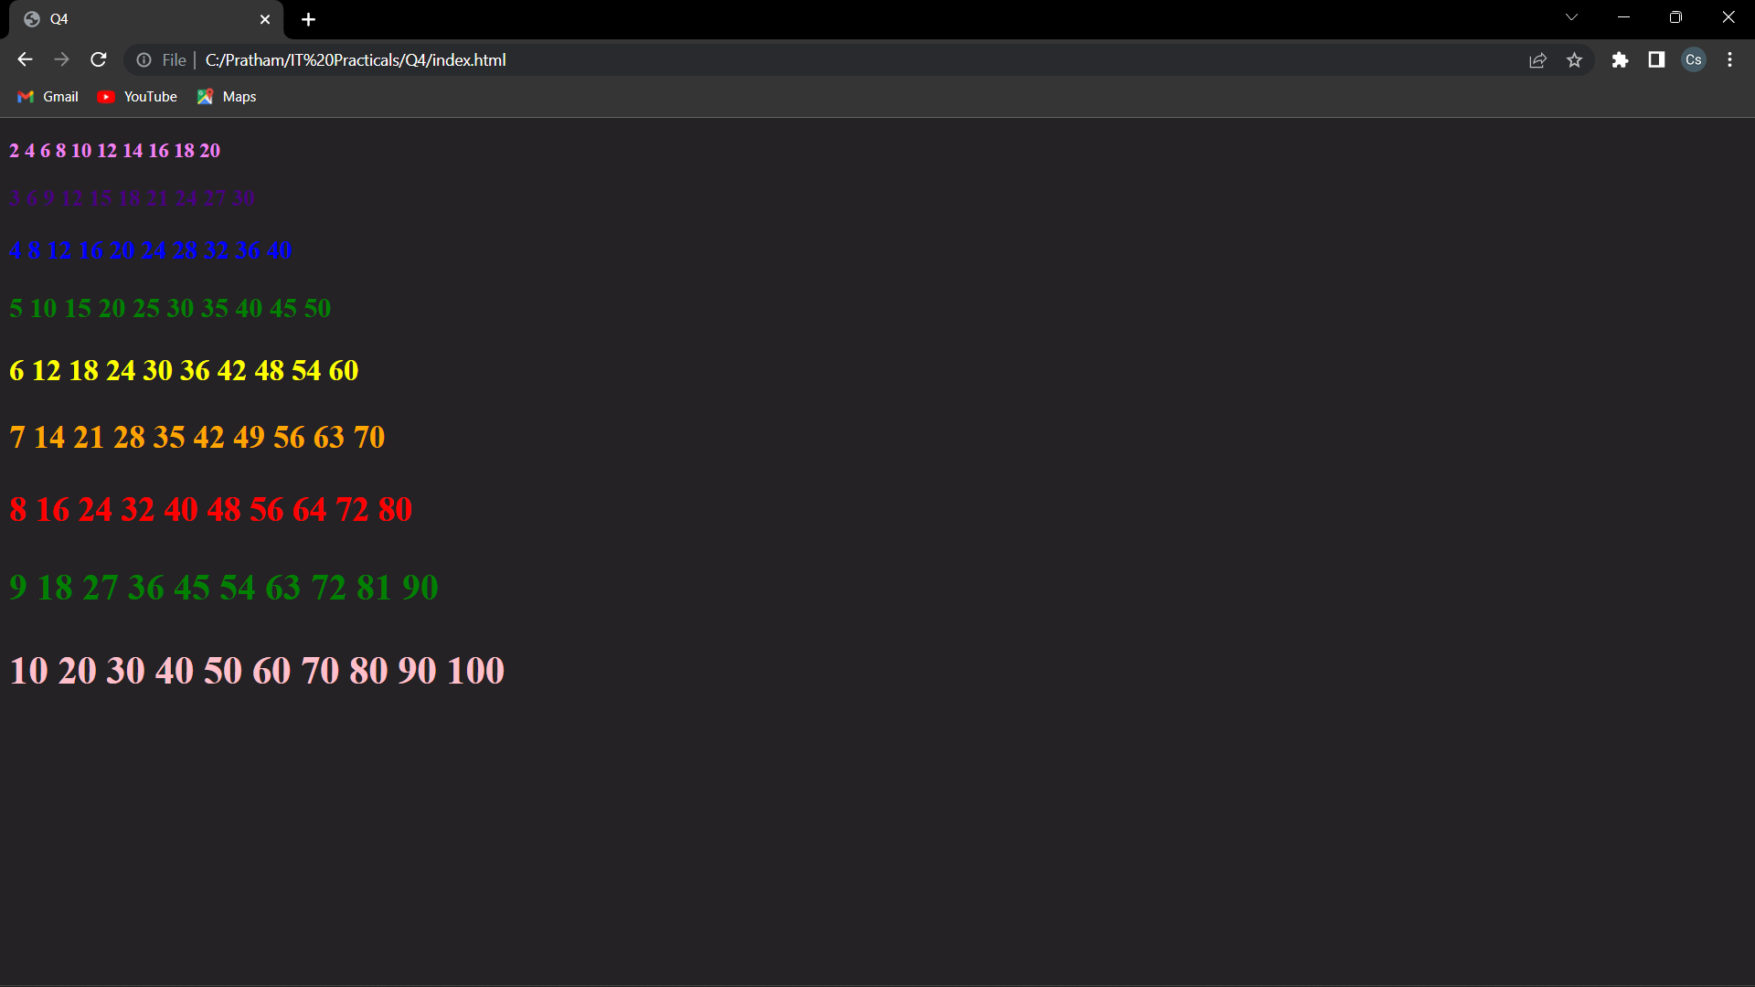

**Question 5**

**CODE**

<!DOCTYPE html>

<html lang="en">

<head>

<meta charset="UTF-8">

<meta http-equiv="X-UA-Compatible" content="IE=edge">

<meta name="viewport" content="width=device-width, initial-scale=1.0">

<link rel="stylesheet" href="./styles.css">

<title>Practical 5</title>

</head>

<style>

#paragraph {

font-family: 'fantasy';

}

button {

width: 75px;

height: 75px;

font-size: 1rem;

background-color: #ababab;

border: none;

border-radius: .8rem;

}

.btn-grid {

display: flex;

flex-direction: column;

row-gap: .5rem;

}

</style>

<body>

<p id="paragraph">

Lorem ipsum dolor sit amet consectetur adipisicing elit. Rem dolore, culpa consequatur hic adipisci libero voluptas harum ad odit dolor officiis aliquam nulla corrupti ipsa eaque qui totam quia aut?

Lorem ipsum dolor sit amet consectetur adipisicing elit. In debitis et dolor adipisci at doloribus qui? Eos facilis adipisci necessitatibus sint possimus, porro modi hic, eveniet ea quidem, nihil expedita.

Labore vitae ducimus consequatur mollitia quaerat fuga dolores doloremque repellendus voluptatem porro eligendi fugiat reprehenderit hic totam, beatae aliquid iste libero debitis omnis! Ipsum error qui, veritatis distinctio atque magni?

Odit est eveniet eum alias quis, necessitatibus saepe sed iste mollitia nihil eaque! Nihil omnis repellendus veritatis sint. Mollitia fuga illo provident consequuntur doloribus, exercitationem quis iste hic maxime ab?

Excepturi rerum error, reiciendis doloremque alias voluptatem nemo distinctio esse, iste voluptas optio porro accusamus similique, nostrum sapiente at. Consequuntur corporis unde, atque explicabo excepturi esse porro ipsam illum cumque!

Fugiat dolore eligendi pariatur veniam incidunt aperiam totam, iure, sint omnis atque, laborum suscipit! Cumque autem fugit nesciunt! Quaerat porro recusandae doloribus debitis, minus ipsa consequatur exercitationem ipsum dolorum consectetur?

</p>

<div class="btn-grid">

<div class="btn-group">

<button class="color-btn">Red</button>

<button class="color-btn">Blue</button>

<button class="color-btn">Green</button>

</div>

<div class="btn-group">

<button class="size-btn">10</button>

<button class="size-btn">20</button>

<button class="size-btn">30</button>

</div>

<div class="btn-group">

<button class="font-btn">Courier</button>

<button class="font-btn">Roman</button>

<button class="font-btn">Verdana</button>

</div>

</div>

<script>

const para = document.getElementById('paragraph')

const colorBtns = document.querySelectorAll('.color-btn')

const sizeBtns = document.querySelectorAll('.size-btn')

const fontBtns = document.querySelectorAll('.font-btn')

const changeColor = (e) => {

const color = e.target.innerText.toLowerCase();

para.style.color = color

colorBtns.forEach((btn) => {

btn.style.backgroundColor = "#ababab"

})

e.target.style.backgroundColor = 'green'

}

const changeSize = (e) => {

const size = parseInt(e.target.innerText.toLowerCase())

console.log(size)

para.style.fontSize = `${size}px`

sizeBtns.forEach((btn) => {

btn.style.backgroundColor = "#ababab"

})

e.target.style.backgroundColor = 'green'

}

const changeFont = (e) => {

const font = e.target.innerText;

console.log(font)

para.style.fontFamily = font

fontBtns.forEach((btn) => {

btn.style.backgroundColor = "#ababab"

})

e.target.style.backgroundColor = 'green'

}

colorBtns.forEach((btn)=>{

btn.addEventListener("click", changeColor)

})

sizeBtns.forEach((btn)=>{

btn.addEventListener("click", changeSize)

})

fontBtns.forEach((btn)=> {

btn.addEventListener('click', changeFont)

})

</script>

</body>

</html>

**OUTPUT**

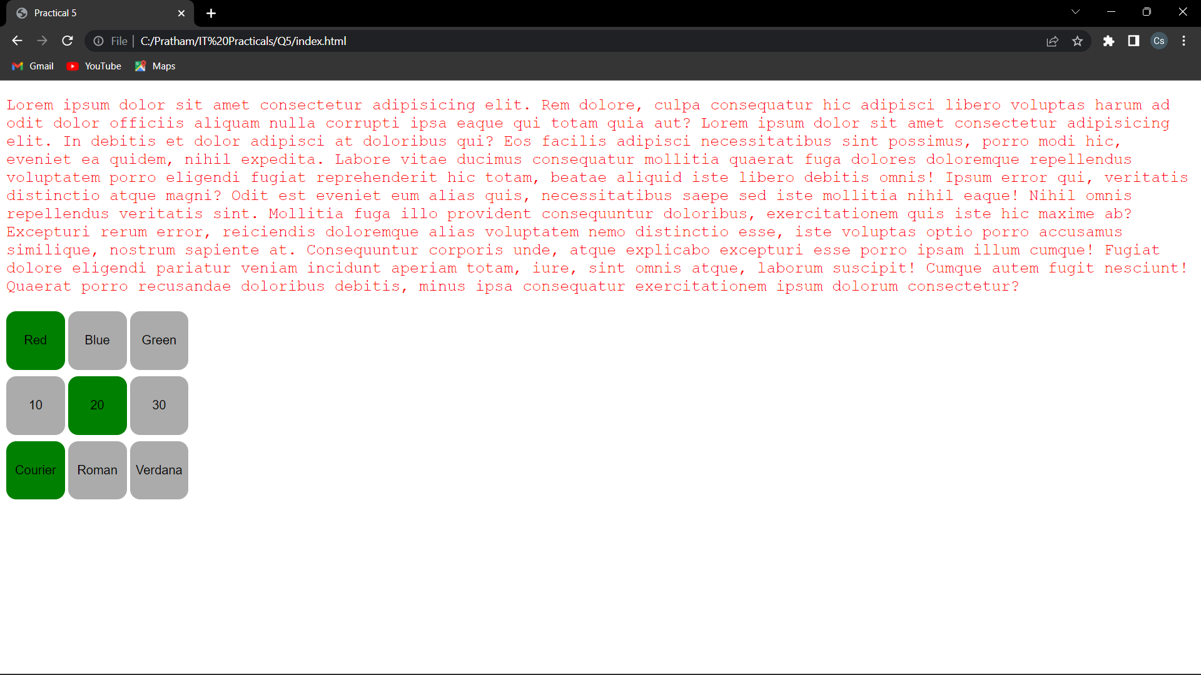

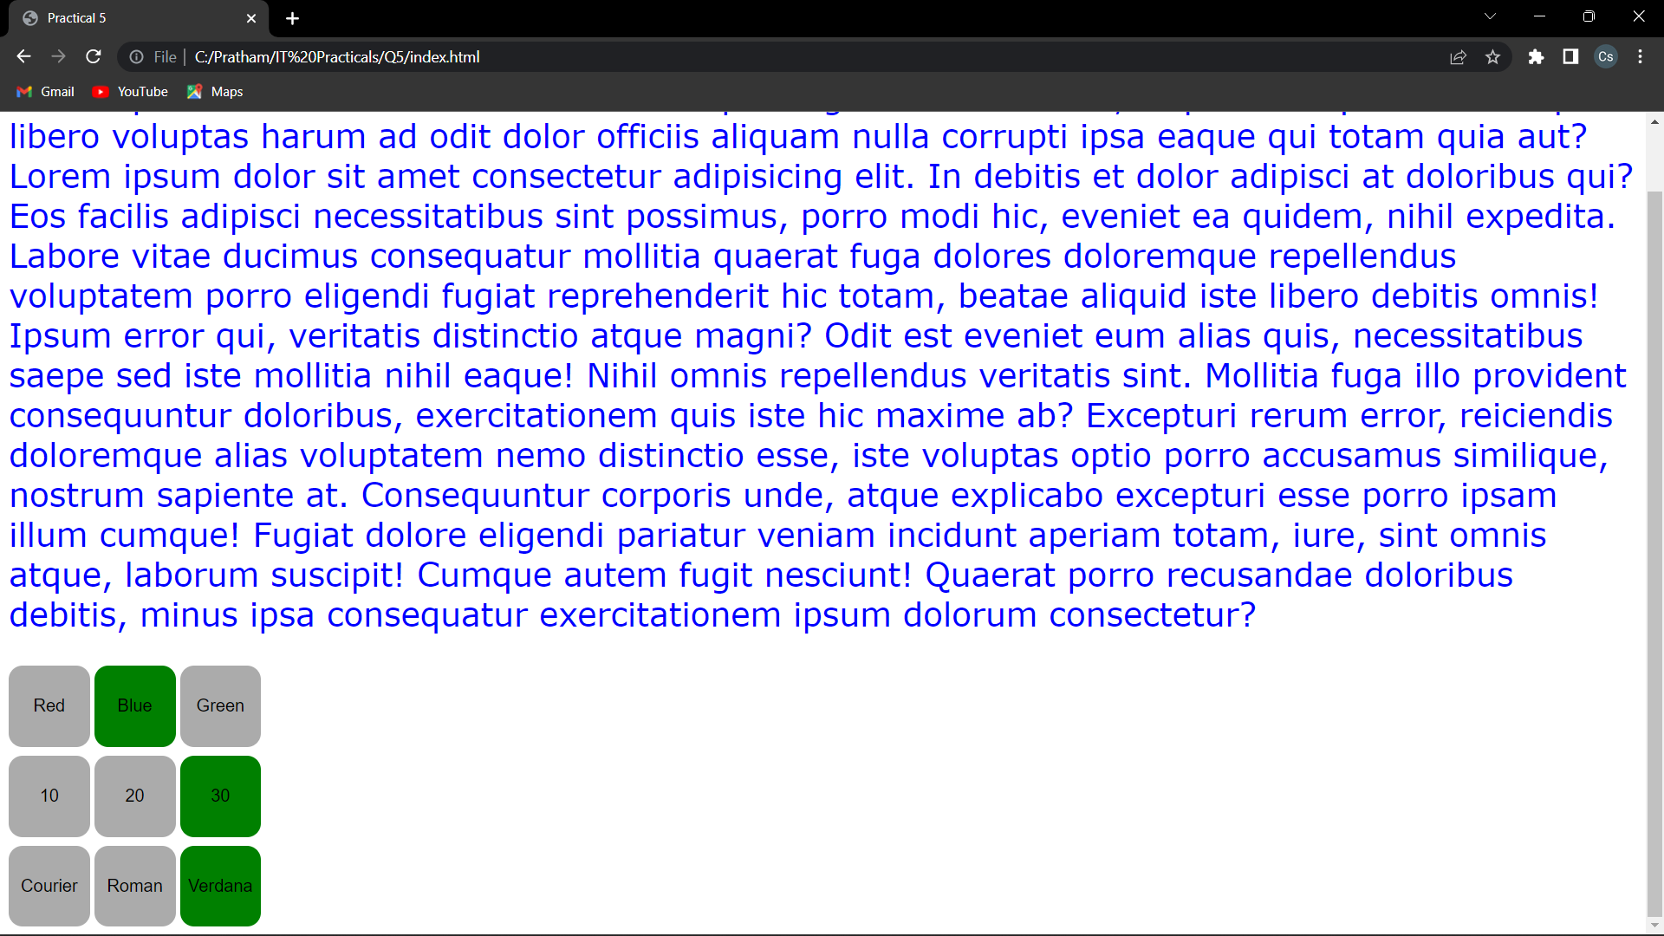

**Question 6**

Create a form that takes data about a pet. The form must be well designed and should accept the pet’s name, age, weight, type, and what it likes most. At the submission of this form create a Pet object in JavaScript filled with these values and log that object and equivalent JSON on the console.

**CODE**

<!DOCTYPE html>

<html lang="en">

<head>

<meta charset="UTF-8">

<meta http-equiv="X-UA-Compatible" content="IE=edge">

<meta name="viewport" content="width=device-width, initial-scale=1.0">

<title>question6</title>

<style>

.main-parent {

width: 100vw;

height: 100vh;

display: flex;

justify-content: center;

align-items: center;

background-color: #ffffff;

color:"white"; }

.form-parent {

display: flex;

flex-direction: column;

padding: 20px;

background-color: #242424;

border-radius: 20px;

gap: 20px;

}

.form-parent>h1 {

text-align: center;

font-size: 28px;

font-family: 'Arial Narrow', Arial, sans-serif;

}

.form-parent>div>input {

font-size: medium;

padding: 5px;

border-radius: .7rem;

border: none;

}

.form-parent>button {

padding: 5px;

background-color: #ff9480;

color: rgb(16, 48, 35);

font-size: medium;

font-weight: bold;

border-radius: 2rem;

border: none;

cursor: pointer;

}

.input-parent {

display: flex;

justify-content: space-between;

align-items: center;

gap: 5px;

}

.main-container {

display: flex;

justify-content: space-between;

padding: 1rem

}

.images-container {

display: flex;

column-gap: 2rem;

align-items: center;

}

img {

width: 400px;

height: 400px;

}

.images-container>img {

border-radius: 2rem;

}

body {

background: #ffffff;

}

label {

color: white;

}

h1 {

color: white;

}

</style>

</head>

<body>

<div class="main-container">

<div class="images-container">

<img style="transform: translate(0px,-50px);" src="https://i.pinimg.com/originals/21/27/2d/21272d7d89d39451737885b05d6d940d.gif" alt="">

<img style="transform: translate(0px,50px);" src="https://cdn.myportfolio.com/df8a6d00-877d-4290-bc3e-8652383d0fb3/ca4dbb7b-587e-485a-969e-55332333bd70_rw_600.gif?h=e1c636787a4879fafc3e1718b96f4617" alt="">

</div>

<div class="main-parent">

<form action="" class="form-parent">

<h1>Enter Pet Information</h1>

<div class="input-parent">

<label for="petname">Pet Name : </label>

<input type="text" id="petname">

</div>

<div class="input-parent">

<label for="age"> Pet Age : </label>

<input type="number" id="age">

</div>

<div class="input-parent">

<label for="weight"> Pet Weight : </label>

<input type="number" name="" id="weight">

</div>

<div class="input-parent">

<label for="type">Pet Breed : </label>

<input type="text" id="type">

</div>

<div class="input-parent">

<label for="like"> Pet Likes : </label>

<input type="text" id="like">

</div>

<button id="submit">Submit</button>

</form>

</div>

</div>

</body>

<script>

const submit = document.getElementById("submit");

submit.addEventListener("click", (e) => {

e.preventDefault();

const name = document.getElementById("petname").value;

const age = document.getElementById("age").value;

const weight = document.getElementById("weight").value;

const type = document.getElementById("type").value;

const like = document.getElementById("like").value;

const nameRegEx = "^[A-Za-z]+$";

if (!name.match(nameRegEx)) return alert("Please Enter Valid First Name");

if (age > 20 || age < 1) return alert("Please Enter valid Age");

const Pet = { name, age, weight, type, like };

console.log(Pet);

const PetJson = JSON.stringify(Pet);

console.log(PetJson);

})

</script>

</html>

**OUTPUT**

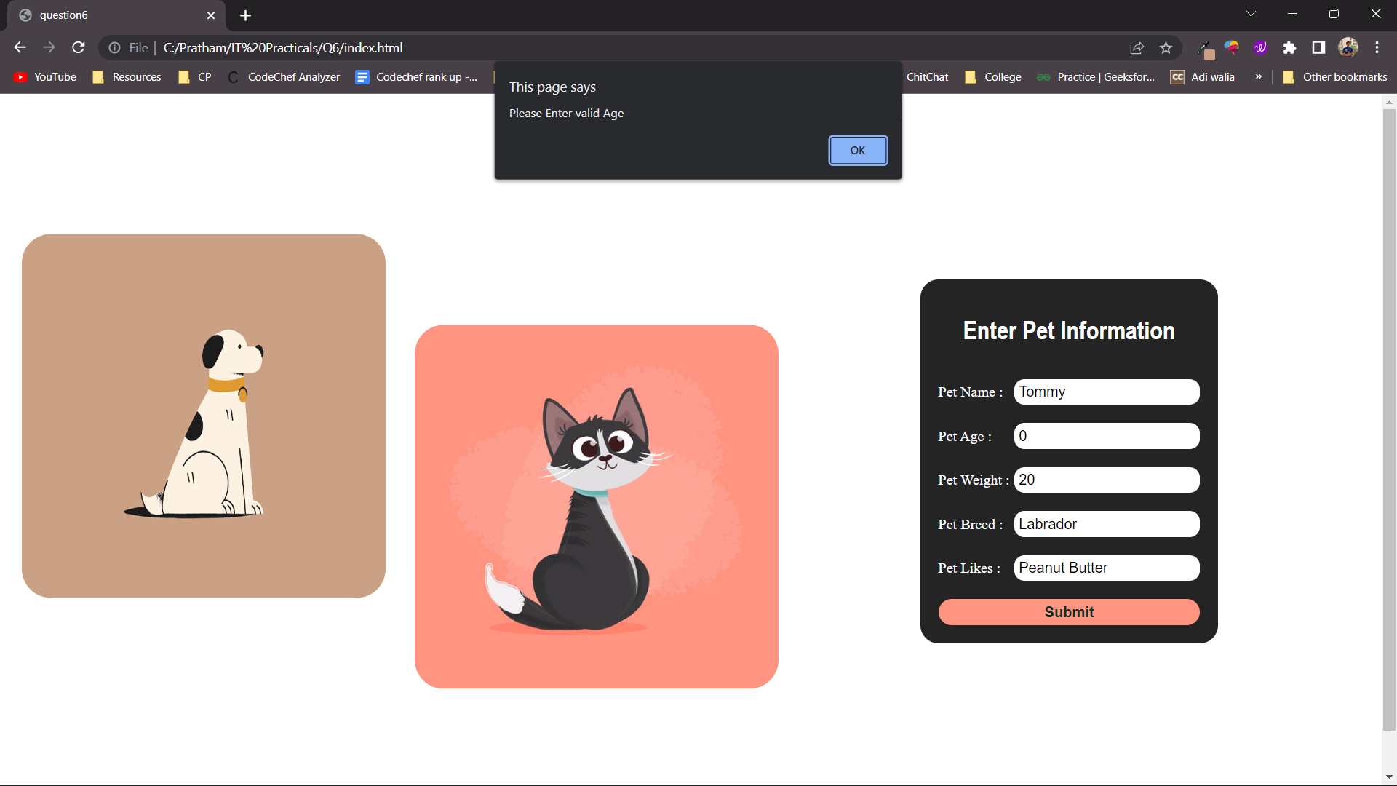

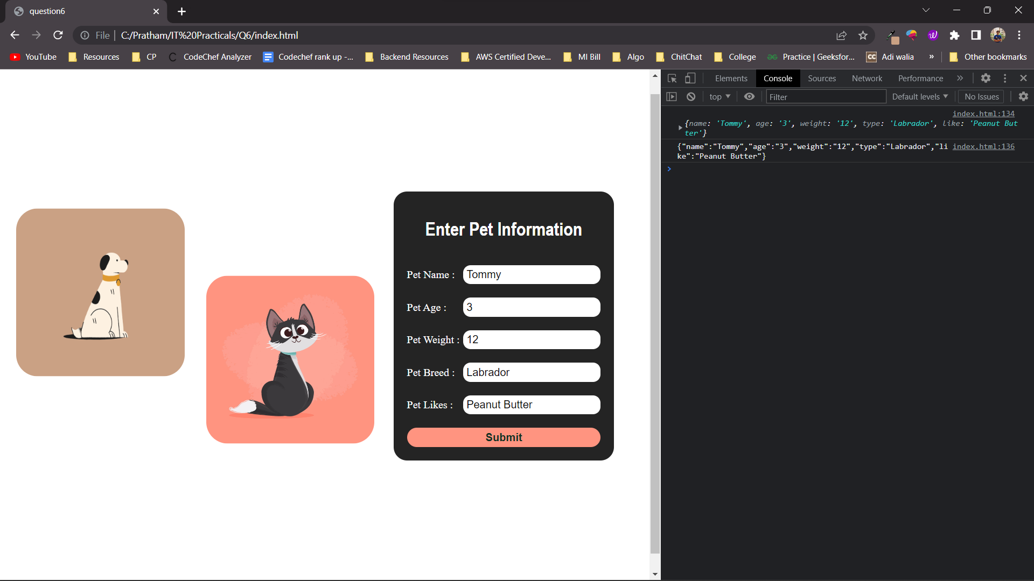

**Question 7**

Store JSON data of few pets that you created in previous practical in a JSON file (copy from console output of previous program to a .json file). Using AJAX, load data from the file and display it in a presentable way using HTML and CSS.

**CODE**

<html lang="en">

<head>

<meta charset="UTF-8">

<title>Ques7</title>

<script src="https://code.jquery.com/jquery-3.5.1.js">

</script>

<style>

table {

margin: 0 100;

font-size: large;

border: 1px solid black;

}

h1 {

margin: 0 250px;

color: red;

font-size: xx-large;

font-family: 'Gill Sans',

'Gill Sans MT', ' Calibri',

'Trebuchet MS', 'sans-serif';

}

td {

background-color: #E4F5D4;

border: 1px solid black;

}

th,

td {

font-weight: bold;

border: 1px solid black;

padding: 10px;

text-align: center;

}

td {

font-weight: lighter;

}

</style>

</head>

<body>

<section>

<h1><u><b>PET DETAIL</b></u></h1><br>

<table id='table'>

<tr>

<th>NAME</th>

<th>AGE</th>

<th>WEIGHT</th>

<th>TYPE</th>

<th>LIKES</th>

</tr>

<script>

$(document).ready(function () {

$.getJSON("pet.json",

function (data) {

var Pet = '';

$.each(data, function (key, value) {

Pet += '<tr>';

Pet += '<td>' +

value.Petname + '</td>';

Pet += '<td>' +

value.Petage + '</td>';

Pet += '<td>' +

value.Petweight + '</td>';

Pet += '<td>' +

value.Pettype + '</td>';

Pet += '<td>' +

value.Petlike + '</td>';

Pet += '</tr>';

});

$('#table').append(Pet);

});

});

</script>

</section>

</body>

</html>

**OUTPUT**

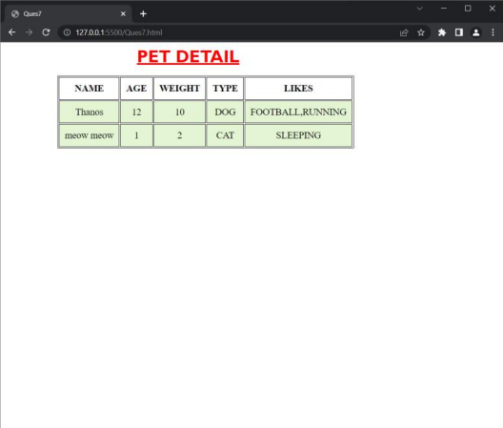 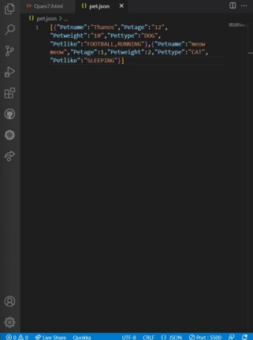

**Question 8**

Create a plain HTML page for B.Sc. Hons CS course, mentioning details like fee, eligibility

criteria, papers with names and credits, and future possibilities after the course. A button for

styling should be there at bottom of the page. On clicking on this button JavaScript should

redesign the complete page using jQuery in a nice presentable way.

**CODE**

<!DOCTYPE html>

<html lang="en">

<head>

<meta charset="UTF-8" />

<meta http-equiv="X-UA-Compatible" content="IE=edge" />

<meta name="viewport" content="width=device-width, initial-scale=1.0" />

<title>Ques8</title>

<script src="https://ajax.googleapis.com/ajax/libs/jquery/3.5.1/jquery.min.js"></script>

<script>

$(document).ready(function () {

$("button").click(function () {

$("button").css({

"background-color": "red",

border: "0px",

borderradius: "10px",

height: "30px",

width: "10%",

"font-weight": "bolder",

color: "white",

marginleft: "100px",

});

$("h1").css({ color: "red" });

$("#first").css({

"margin-left": "250px",

color: "red",

display: "inline-block",

});

$("body").css({

border: "5px solid black",

"border-radius": "15px",

margin: "30px 100px",

});

});

});

</script>

</head>

<body>

<div id="first">

<h1>B.Sc. Hons CS</h1>

<h3>Fees</h3>

<h3>Elgibility Criteria</h3>

<h3>Paper</h3>

<h3>Future Scope</h3>

</div>

<div id="second" style="display: inline-block">

<h3>: 90K(approx)</h3>

<h3>: Mathematics and Computer Science</h3>

<h3>

: Language Papers,Algorithms, Data Structures,DBMS,Microprocessors.etc

</h3>

<h3>: Software Development, Research Work</h3>

</div>

<br />

<button onclick="change()">CHANGE STYLE</button>

<br /><br /><br />

</body>

</html>

**OUTPUT**

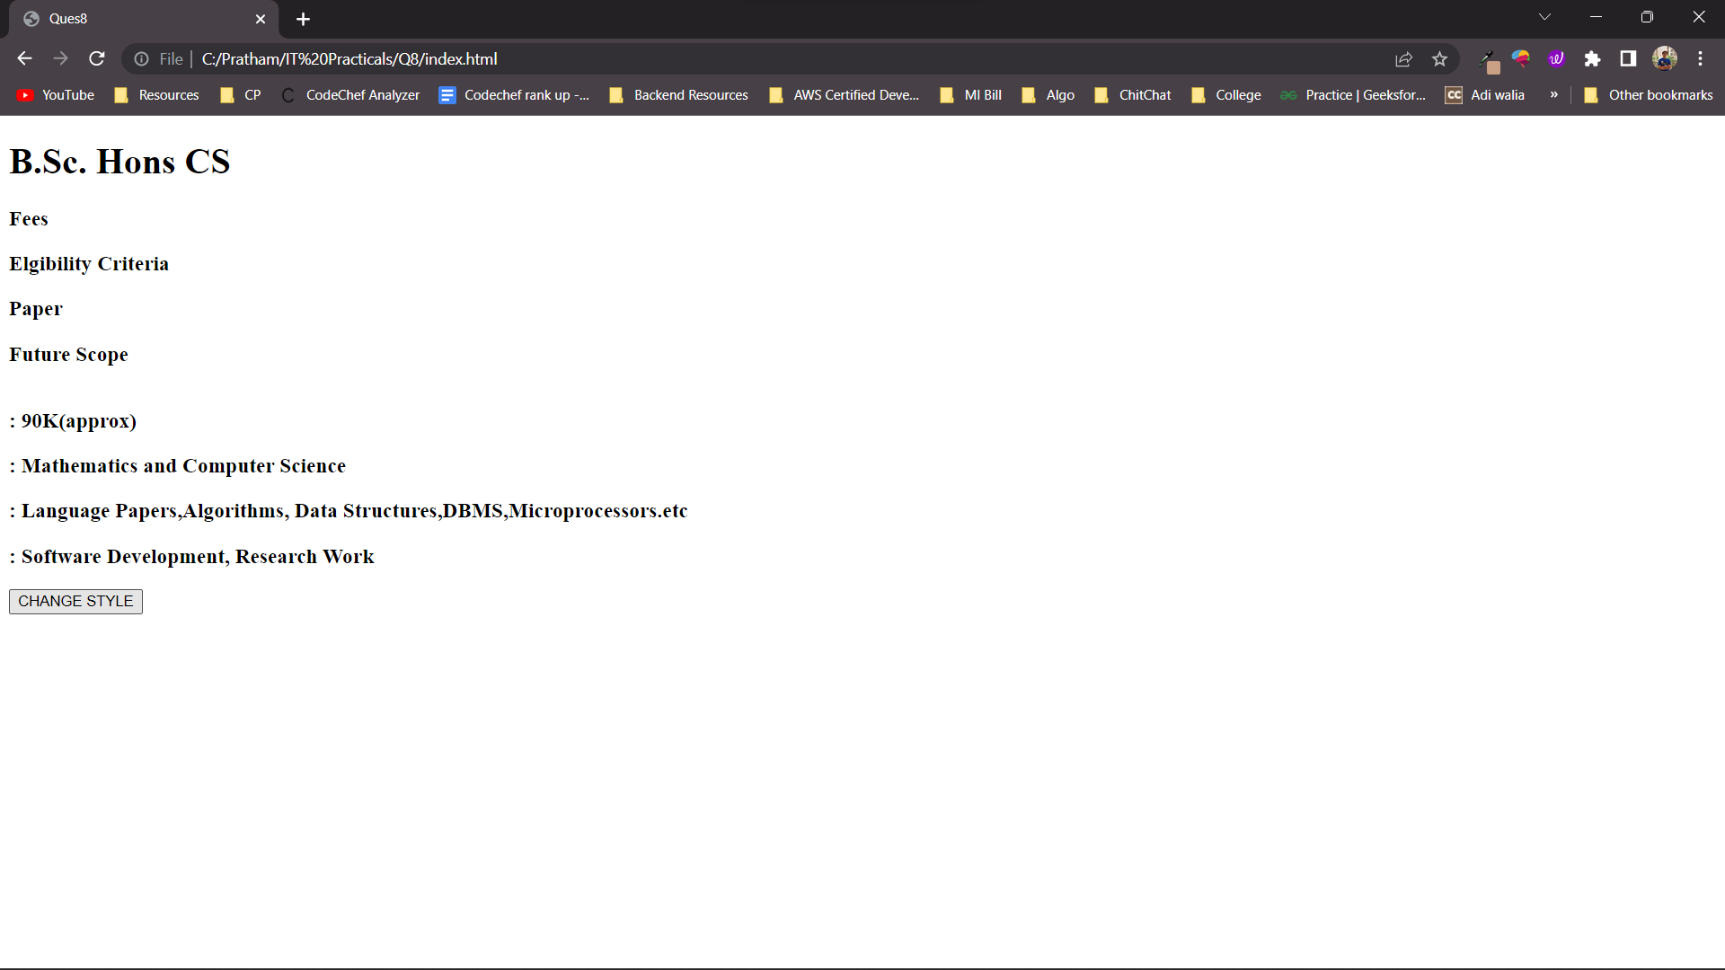

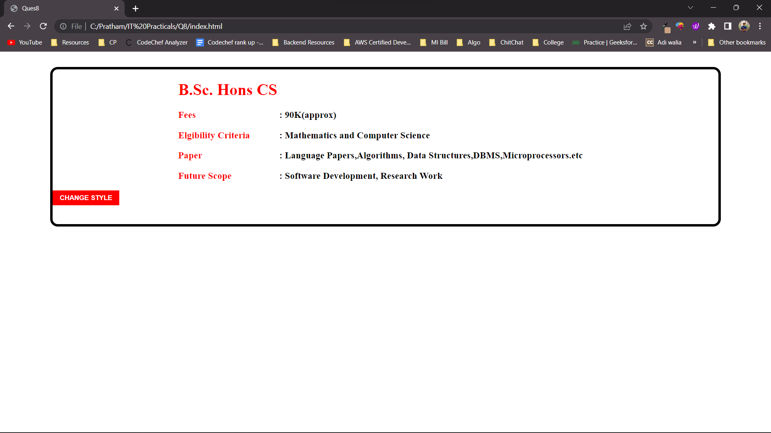

**Question 9**

Create an HTML page for an image gallery which shows the use of BOOTSTRAP to rearrange and resize its contents on resizing the browser.

**CODE**

<!DOCTYPE html>

<html lang="en">

<head>

<meta charset="utf-8" />

<meta name="viewport" content="width=device-width, initial-scale=1" />

<title>Ques 9</title>

<link

href="https://cdn.jsdelivr.net/npm/bootstrap@5.2.0/dist/css/bootstrap.min.css"

rel="stylesheet"

integrity="sha384-gH2yIJqKdNHPEq0n4Mqa/HGKIhSkIHeL5AyhkYV8i59U5AR6csBvApHHNl/vI1Bx"

crossorigin="anonymous"

/>

<style>

img {

width: 300px;

margin: 5px;

}

</style>

</head>

<body>

<img src="1.jpg" class="rounded float-start" alt="..." />

<img src="2.jpg" class="rounded float-end" alt="..." />

<img src="3.jpg" class="rounded float-start" alt="..." />

<img src="4.jpg" class="rounded float-end" alt="..." />

<img src="5.jpg" class="rounded float-start" alt="..." />

<img src="6.jpg" class="rounded float-end" alt="..." />

<img src="7.jpg" class="rounded float-start" alt="..." />

<img src="8.jpg" class="rounded float-end" alt="..." />

<img src="9.jpg" class="rounded float-start" alt="..." />

<img src="10.png" class="rounded float-end" alt="..." />

<script

src="https://cdn.jsdelivr.net/npm/bootstrap@5.2.0/dist/js/bootstrap.bundle.min.js"

integrity="sha384-A3rJD856KowSb7dwlZdYEkO39Gagi7vIsF0jrRAoQmDKKtQBHUuLZ9AsSv4jD4Xa"

crossorigin="anonymous"

></script>

</body>

</html>

**OUTPUT**

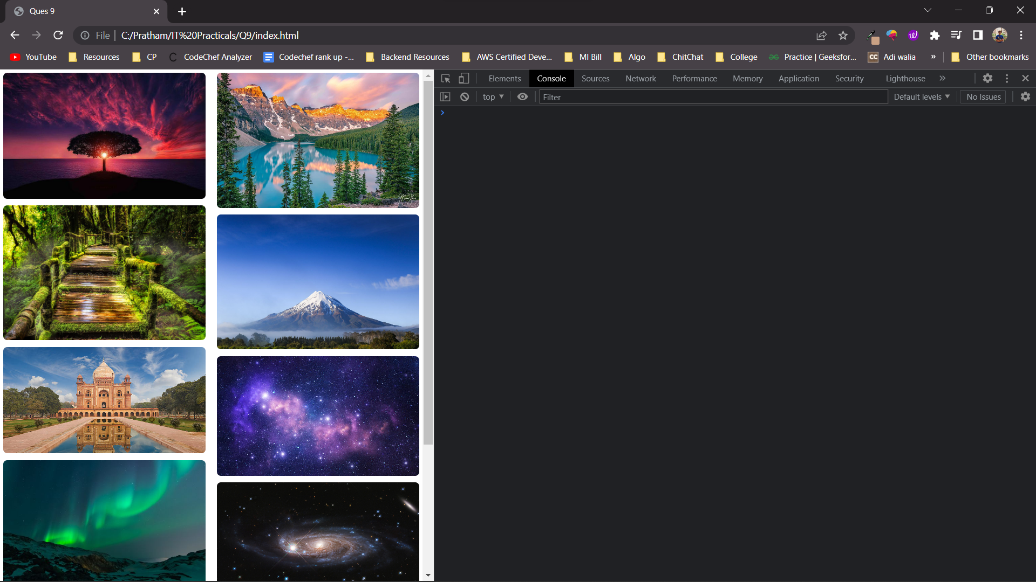

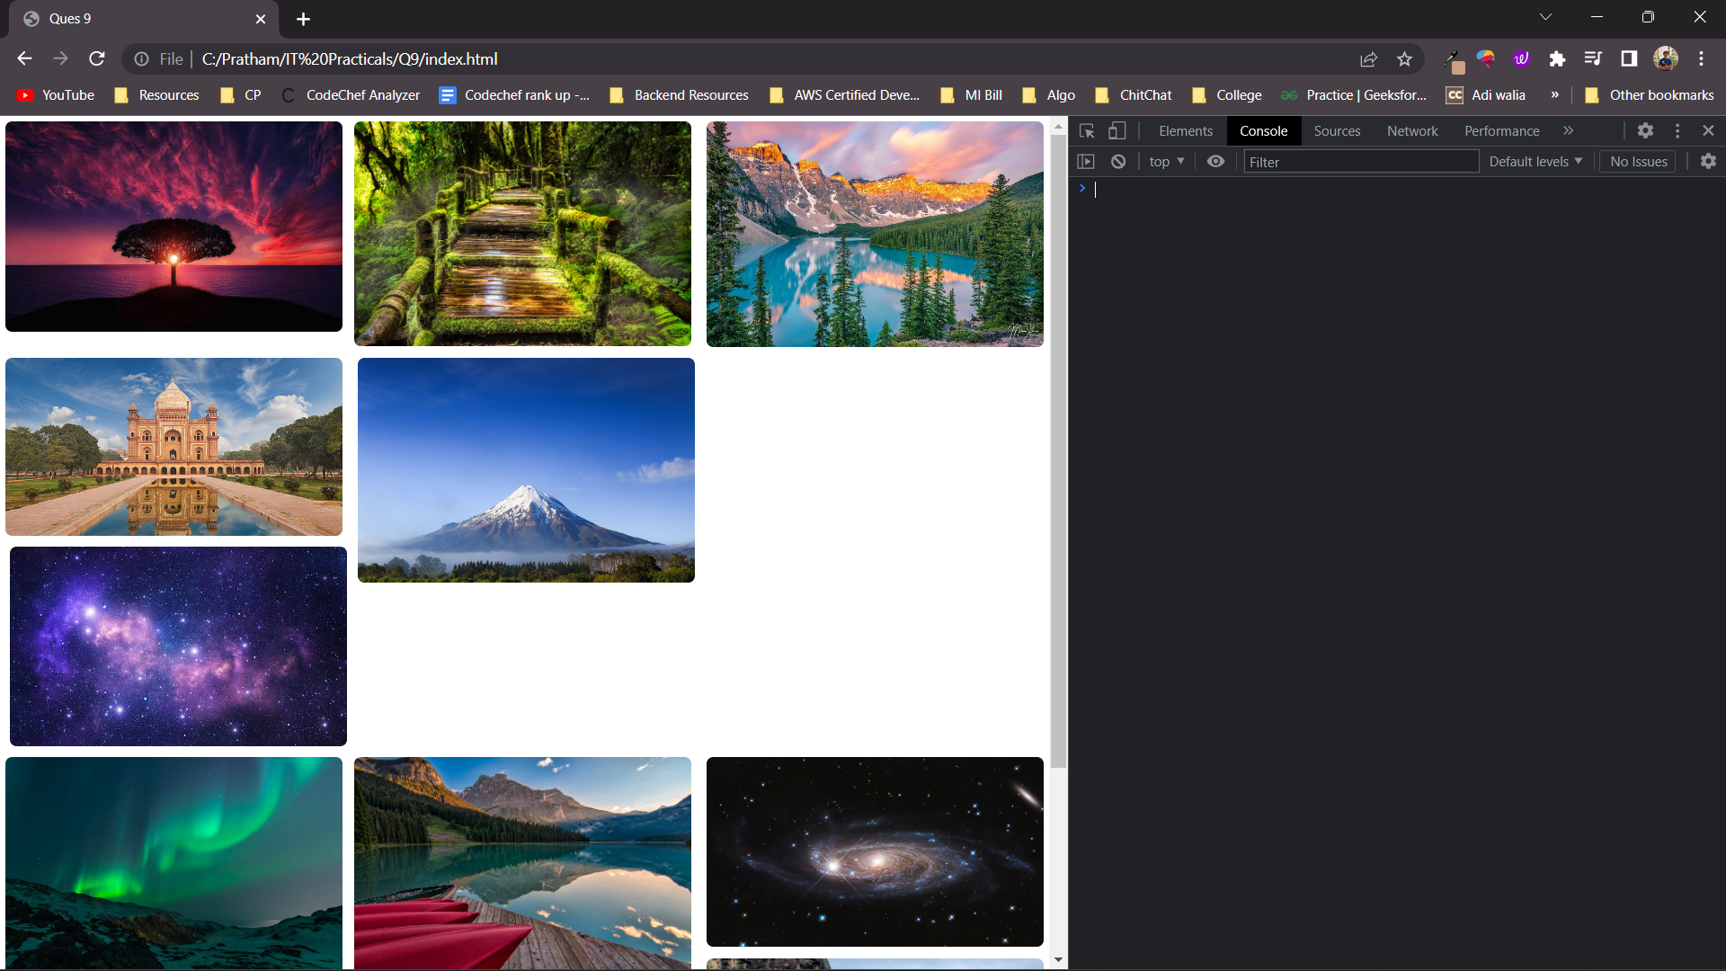

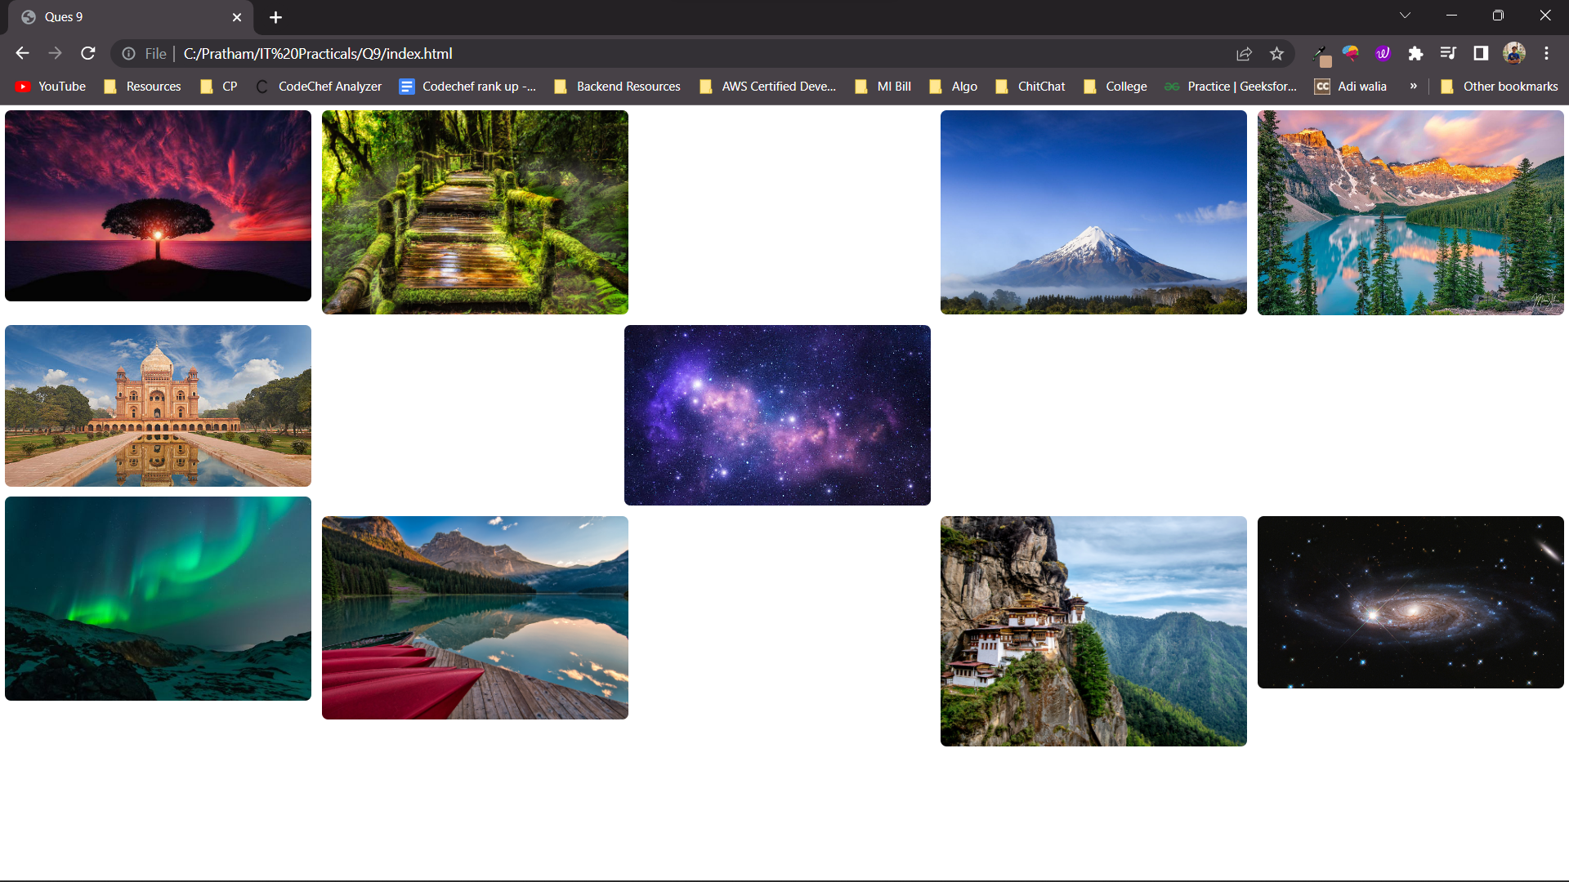

**Question 10**

Create an HTTP server using Node.js which handles requests on port 10000 or a free port beyond 10000. Modify the server in such a way that opening localhost:10000 will display “Hello world, This is my Node.js server” on browser.

**CODE**

**index.html**

<!DOCTYPE html>

<html lang="en">

<head>

<meta charset="UTF-8" />

<meta http-equiv="X-UA-Compatible" content="IE=edge" />

<meta name="viewport" content="width=device-width, initial-scale=1.0" />

<title>Ques10</title>

</head>

<body>

<h2>Hello world, This is my Node.js server</h2>

</body>

</html>

**Index.js**

var http = require("http");

var fs = require("fs");

var ports = [10000, 10001, 10002];

const { listenerCount } = require("process");

fs.readFile("./index.html", function (err, html) {

if (err) {

console.log(err);

}

ports.forEach(function (port) {

http

.createServer(function (request, response) {

response.writeHeader(200, { contentType: "text/html" });

response.write(html);

response.end();

})

.listen(port);

});

});

**OUTPUT**

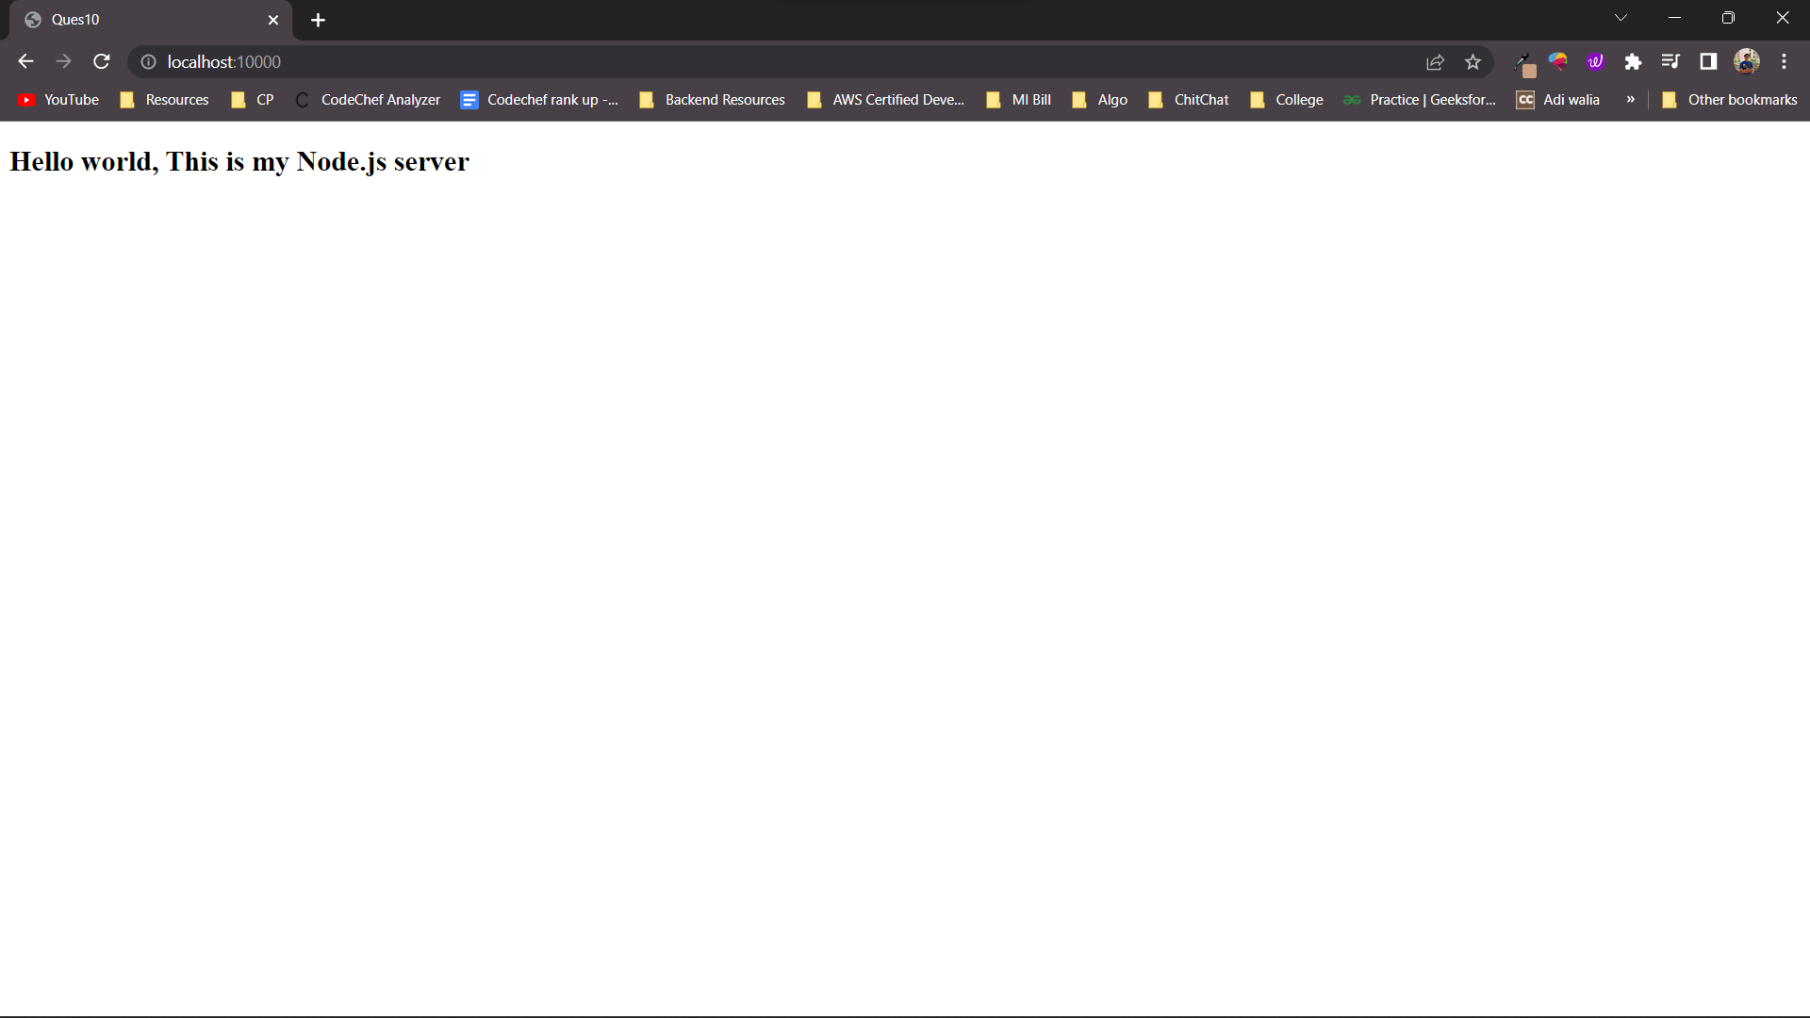

**Question 11**

Create index.html file containing two forms for SignIn and SignUp. Submitting SignIn form should search for credentials in mysql database using server created in previous practical. On successful signin, a welcome page should be displayed. Submitting SignUp form should insert new entry for credentials in mysql database using server created in previous practical. On successful signup, user should be returned back to index.html.

**CODE**

**CODE**

**Index.html**

<!DOCTYPE html>

<html lang="en">

<head>

<meta charset="UTF-8" />

<meta http-equiv="X-UA-Compatible" content="IE=edge" />

<meta name="viewport" content="width=device-width, initial-scale=1.0" />

<title>Ques11</title>

</head>

<body>

<div

id="signup"

style="

border: 4px solid black;

display: inline-block;

width: 40%;

height: 450px;

"

>

<h2 style="text-align: center">

<u><b>Enter Signup Details</b></u>

</h2>

<div style="display: inline-block; position: absolute; left: 100px">

* Name <br /><br />

* Age <br /><br />

* Phone <br /><br />

* Gender <br /><br />

* Password<br /><br />

</div>

<div style="display: inline-block; position: absolute; left: 230px">

<form action="submit.php" method="post">

<input type="text" value="" name="NAME" /><br /><br />

<input type="int" value="" name="AGE" /><br /><br />

<input type="text" value="" name="PHONE" /><br /><br />

<input type="text" value="" name="GENDER" /><br /><br />

<input type="password" value="" name="PASSWORD" /><br /><br />

<input

type="submit"

value="Signup"

style="

background-color: red;

border: 0px;

width: 50%;

height: 30px;

border-radius: 10px;

color: white;

font-size: large;

font-weight: bold;

"

/>

</form>

</div>

</div>

<div

id="signin"

style="

border: 4px solid black;

display: inline-block;

width: 40%;

height: 450px;

"

>

<h2 style="text-align: center">

<u><b>Enter Signin Details</b></u>

</h2>

<div style="display: inline-block; position: absolute; left: 740px">

* Phone <br /><br />

* Password<br /><br />

</div>

<div style="display: inline-block; position: absolute; left: 850px">

<form action="verify.php" method="post">

<input type="text" value="" name="PHONE" /><br /><br />

<input type="password" value="" name="PASSWORD" /><br /><br />

<input

type="submit"

value="Signin"

style="

background-color: red;

border: 0px;

width: 50%;

height: 30px;

border-radius: 10px;

color: white;

font-size: large;

font-weight: bold;

"

/>

</form>

</div>

</div>

</body>

</html>

**Submit.php**

<?php

$con = mysqli_connect("localhost", "root", "");

if (!$con) {

die("Connection Failed;)" . mysqli_connect_error());

} else {

$name = $_POST['NAME'];

$age = $_POST['AGE'];

$phone = $_POST['PHONE'];

$gender = $_POST['GENDER'];

$password = $_POST['PASSWORD'];

$sql = "INSERT INTO `Ques11`.`data` ( `Name`, `age`, `phone`, `gender`, `password`, `time`)

VALUES ( '$name', '$age', '$phone', '$gender', '$password', current_timestamp());";

$con->query($sql);

// alert("Success");

echo '<script>alert("Success"); window.open("index.html");</script>';

}

?>

**Verify.php**

<?php

$con = mysqli_connect("localhost", "root", "");

if (!$con) {

die("Connection Failed;)" . mysqli_connect_error());

} else {

$s1 = 0;

$s2 = 0;

$phone = $_POST['PHONE'];

$password = $_POST['PASSWORD'];

$sql = "SELECT `phone`,`password` FROM `Ques11`.`data` ;";

$row = mysqli_query($con, $sql);

while ($one = mysqli_fetch_array($row)) {

if ($one[0] == $phone) {

$s1 = 1;

if ($one[1] == $password) {

$s2 = 1;

break;

}

}

}

if ($s1 == 1 && $s2 == 1) {

echo '<script>alert("Welcome");</script>';

} else {

echo '<script>alert("NO_DATA_FOUND"); window.open("index.html","_self");</script>';

}

}

?>

**OUTPUT**